# Introduction

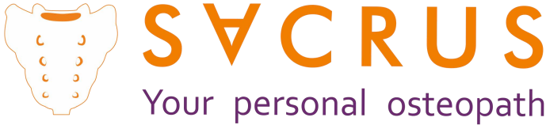

**USER MANUAL**

**CAUTION! Do not use this product without first reading EVERY PAGE in this manual.**

**Results will depend on the correct use of SACRUS.**

SACRUS is designed to restore the normal functioning state of the sacrum, atlas and diaphragm.

Most people that experience childbirth trauma, childhood falls, a sedentary life style, or high endurance sports activities, etc., have the sacrum and atlas (first cervical) misaligned and spasmed, while the dia- phragm is affected (tensed) by daily stress. The sacrum, the base of the skull and the diaphragm are the most important biomechanical centers of the body. Any alteration caused directly to these points will lead to chronic fatigue of the spine and important internal organs. As a result, serious illnesses may develop that can negatively affect the immune system. SACRUS is able to re-establish the functionality of these centers by applying a gentle osteopathic discharge.

It´s not only a great solution for people with back problems, but also for high performance athletes, office workers, yogis, amongst others.

The self-auto-gravitational method adapted by SACRUS is safe, non-invasive and physiologically natural to the spine because the device works with the body’s own weaight. It also provides the same benefits as re- ceiving magnetic therapy, acupressure, passive yoga or deep massage, all in one economic efficient device. These methods have been used since the times of ancient oriental medicinal procedures. SACRUS can be used at home as well as by specialists.

##### SACRUS can be used on individuals from age 10 and older with a height of greater than 1.50 centi- meters.

**It is essential to obtain a diagnosis with a spine specialist. Do not apply SACRUS in contra- indicated areas (see pages 2, 3 and 4).**

**If a condition within your diagnosis is not described in this manual , you must obtain au- thorization from your Doctor before using Sacrus.**

**SACRUS is recommended in case of:**

* Piriformis syndrome, buttock and sacral pain, pinched sciatic nerve, carpel tunnel syndrome, knee pain, organ dysfunction in the small pelvis, sexual dysfunction (of the sexual organs), sacroiliitis.
* Intercostal neuralgia, diaphragmatic breathing disorders, vertebrogenic gastrointestinal dysfunction.
* Reduces seizures and muscle stiffness in children with cerebral palsy.
* Chronic muscular overload and biomechanical failures in the musculoskeletal system, caused by cons- tant intensive athletic training.
* Back and neck pains due to muscular overload, often related to static posture and professional weight

lifting.

* Osteochondrosis at any location, 1st through 3rd degree scoliosis, 1st through 3rd degree kyphosolio- sis, juvenile osteochondropathy (Sheyerma-Mau disease), incorrect posture, delayed growth of children and adolescents.
* Headaches of different origin, deficiency of blood circulation within the brain, cervical neck pathologies,

spinal arterial syndrome, insomnia and occipital nerve neuralgia.

* Correction of the base of the skull may help in case of cranial and extracranial problems: headaches, migraines, myopia, hyperopia, neck pains, cervical osteochondrosis, cervical spine instability, cervical spine protrusion, difficulty with nasal breathing, vertebral artery syndrome, occipital neuralgia, slee- ping disorders.
* Dysfunctions of the autonomous nervous system caused by biomechanical failures in the locomotive segments of the spine, cardiac problems, pectoral angina, coronary disease (myocardial ischemia), hypotonic or hypertonic neuro dystonia; vision and hearing dysfunctions (after suffering from periphe- ral blood circulation failure), vesicular dyskinesia, sudden interruptions or changes in the bronchi and lung function, stomach, intestine, liver, pancreas, kidneys and genitourinary system, as long as there is no life-threatening injury to a specific organ.
* Myofascial pain syndrome and mobility restrictions of the neck, thoracic and lumbar regions from deve- loping functional blockages of the spinal segments (intervertebral muscle spasms); discalgia, lumbago (low back pain), sciatica, toralgia, neck pain.
* Pain syndrome, from protrusion (something that bulges out) of the fibrous ring within the interverte- bral disc (herniated disc); carpal tunnel syndrome, peripheral nervous syndromes, numbness of the hands, “frozen shoulder” syndrome and shoulder epicondylitis.

# Contraindications

* Specific and non-specific infectious processes in the spine and joints (spinal osteomyelitis, tuberculous spondylitis, ankylosing spondylitis).
* Tumors along the spine and spinal cord, malignant neoplasms found at any location.
* Recent traumatic injuries to the spine and severe head injuries.
* Severe cerebrovascular circulation disorders (stroke, atherothrombosis, vertebral artery blockage, etc.)
* 3rd and 4th degree scoliosis affecting the curvature of the spine.
* Herniated intervertebral discs with rupture of the fibrous ring.
* Complete lack of movement of the joints (ankylosis).
* Severe instability of the spinal segments (3rd and 4th degree), derived from the condition of spondylo- listhesis.
* Severe diseases of the internal organs.
* Epilepsy.
* Pregnancy (2nd and 3rd trimesters)

##### If you have back massages prohibited do not use SACRUS.

**You can also consult other limitations within the sections of SPECIAL DIAGNOSTICS or PARTICULAR**

**CASES.**

**Special Diagnostics:** For certain diagnosis, it is recommended NOT to place SACRUS directly on the da- maged area; in these cases, the correct method of use is to avoid the affected areas by simply placing the device along the rest of the undamaged regions of your back. Since the spine is a connected system; any improvement gained within the structure of your spine will give benefits to other areas.

**ARTHRITIS / ARTHRHOIS:** Do not apply the device directly on affected areas, instead position it 3 cm (1.2 inches) above or below this point. We recommend that our clients take anti-inflammatory medicines and undergo magnetic therapy at least twice a year.

**SPASTIC BRAIN PARALYSIS IN CHILDREN:** In mild cases, it may complement other treatments. **CERVICALGIA:** During the first three sessions, place SACRUS on the basic points of your spine. You will then concentrate more attention to the cervical and trapezius zones (apply to every vertebra in each of these zones).

**COXARTHROSIS:** Do not apply SACRUS to damaged areas.

**VERTEBRAE DISPLACEMENT:** Avoid placing the device directly on damaged regions. Place SACRUS direct-

ly to areas close the problem, 3 cm (1.2 inches) above or below the affected area.

**SPLICED, CLOSED OR JOINED DISCS:** Avoid this damaged zone and work nearby areas, 3 cm (1.2 inches) above or below.

**SCIATIC PAIN (HIPS AND FEET):** Execute a basic discharge of the sacrum. It is recommended to comple-

ment your therapy with the CORDUS device.

**SHOULDER PAIN:** Same use as in cervicalgia. Also, apply SACRUS to the zone below the shoulder blades. **KNEE PAIN:** Concentrate most of the therapy to the sacrum area and remember to also include additional points applied to below the knees.

**SCOLIOSIS:** Use SACRUS moderately*, by incorporating the use of supports. Execute recommended exerci- ses to treat adequately this disease. Only to treat 1st and 2nd degree.

**SPONDILOLISTESIS, LISTESIS AND RETROLISTESIS:** Do not apply SACRUS to damaged zones. Only place

the device on nearby areas, 3 centimeters (1.2 inches) above or below the affected region.

**ANQUILOSANT SPONDILITIS:** SACRUS can provide relief and it can be applied up to twice a day. Do not apply the device where the vertebrae have already merged (joined).

**STENOSIS:** SACRUS will help remove muscle spasms in areas close to the damaged region, instantly redu- cing de pressure of intervertebral discs and effectively decelerating the stenosis process. During the first month of using SACRUS, apply it to the areas without stenosis. At the end of the month, apply it directly but moderately to the damaged area *

**FIBROMYALGIA:** Use SACRUS as an additional complement to your doctor’s recommended therapy. Use the device at a moderate pace during the night hours within a quiet environment.

**FIBROSIS:** If the condition is determined to be within the muscles near the vertebrae, avoid applying SA- CRUS directly to the damaged area. Place SACRUS on nearby areas, 3 centimeters (1.2 inches) above or below the affected region.

**DISC FRACTURE:** SACRUS cannot be applied to a fractured zone. You can use it on nearby areas, 9 cm (3.5 inches) above or below the affected region.

**GONARTROSIS:** Avoid applying device directly to damaged areas. Place it on nearby segments, 3 cm (1.2

inches) above or below.

**HERNIATED DISCS:** For basic application, it is recommended to complement your therapy with the COR- DUS device.

If the fibrous ring is ruptured, SACRUS will not be able to help you. If you need to use it to treat other pro- blems along the spine, apply 9 cm (3.5 inches) above or below the area with the ruptured fibrous ring.

**HYPERLORDOSIS:** For basic application, it is recommended to complement your therapy with the CORDUS

device.

**LUMBALGIA:** For basic application, it is recommended to complement your therapy with the CORDUS de- vice.

**OSTEOARTHRITIS:** Do not apply SACRUS directly to the damaged area. We advise customers to use the device after taking inflammatory medicaments. (Consult with your specialist.)

**OSTEOCONDROSIS:** Apply basic therapy.

**OSTEOOPHYTES:** If you feel pain while applying SACRUS to a certain point, avoid the affected region and

proceed to treat the surrounding areas.

**OSTEOPENIA (PRE-OSTEOPOROSIS):** SACRUS can be applied in a moderate* manner.

**OSTEOPOROSIS:** SACRUS should only be applied to areas not affected by this disease.

**FOOT ASLEEP:** For basic application, it is recommended to complement your therapy with the CORDUS

device.

**POLYOMYELITIS:** Use SACRUS in a moderate* manner by incorporating supports. Perform the recommen- ded exercises for this disease. Only for 1st and 2nd degree.

**RADICULITIS - RADICULOPATHY:** For basic application, it is recommended to complement your therapy

with the CORDUS device.

**ROTOESCOLIOSIS:** Use SACRUS in a moderate* manner by incorporating supports. Perform the recom- mended exercises for this disease. Only for 1st and 2nd degree.

**DISPLACED VERTEBRAE:** Avoid placing directly on the damaged area. Apply SACRUS to areas close to the

problem, 3 cm (1.2 inches) above or below the affected region.

**FUSED VERTEBRAES (joined):** Avoid the damaged area, use 3 cm (1.2 inches) above or below.

**Use of SACRUS in particular cases**

SPINAL SURGERY: SACRUS can be used six months after undergoing a surgical procedure. Remember to

start moderately *.

DIABETES Type 1: The application of SACRUS normally reduces the glucose levels. Therefore, we suggest that you measure your level before and after each session is completed, in order to carry out an adequate control. Talk to your doctor about whether or not you should reduce your medication based on your con- tinuous use of SACRUS or CORDUS, since these devices might have a positive impact on reducing your glu- cose level. We suggest alternating the daily use of each device, one day SACRUS and another day CORDUS. PREGNANCY: Use the device only on the cervical and dorsal areas (above the shoulder blades).

HYPERTENSION: In some cases, the use of SACRUS in the cervical and thoracic areas, can cause anxiety and raise the pressure. We recommend using SACRUS during the first month on the lumbar-sacral area, where it will provide improvements to blood circulation. If necessary use it moderately* and keep control of your blood pressure.

HYPOTENSION: Since people with low pressure can feel a little dizzy when finalizing each session, we hi- ghly recommend our clients to use the device before going to bed.

PACEMAKER: SACRUS has neodymium magnets. For safety reasons, we strongly recommend removing

them before starting to use the SACRUS.

HEART PROBLEMS: If you do not have massages prohibited, SACRUS should only be placed on the lower

back and coccyx areas.

If you have any doubts, please write t[o contacto@SACRUS.com](mailto:contacto@SACRUS.com)

Visit SACRUS.com for additional information and video instructives.

We suggest getting an x-ray of your spine and having these results revised by a doctor. This way you will know the contraindications based on the condition of your spine and diagnosis.

# Preparing Session with SACRUS

The session can be performed on a bed or on the floor. Find the best way to accommodate yourself. You will experience excellent results in whichever position you decide to select.

Before starting the therapy, you should proceed to prepare the supports in order to be able to control and reduce the pressure being exerted by the SACRUS: pillows or towels and a blanket to avoid drafts. Remem- ber to set an alarm to avoid falling asleep. If you decide to do the session on the floor, make sure to use a folded blanket or non-slip mat. We highly recommend that you turn off your cell phone device and try to obtain a state of complete relaxation. Try not to talk nor use your computer, television or any other device that may distract your concentration during the relaxation process. Seeking and obtaining a deep relaxa- tion is an essential part of the therapy. It is advisable to warm your back before staring the session by sim- ply spending a few minutes sitting on the couch, lying in bed or using a heating pad.

*Do not rush. Take the necessary time to learn how to properly execute your therapies.*

**Breathing and Relaxation**

#### The use of SACRUS should be enjoyable and relaxing. Avoid talking, using cell phone, computer, watching television or other distractions.

During the use of SACRUS, it is necessary to breathe with the diaphragm (the “effort” or muscular movement is centered in this lower part of the lungs) and seek to obtain deep relaxation. Concen- trate your attention on every breath you take and on the focus of your tension; try to mentally relax this point. Inhale calmly with the lower part of your lungs and pause for a few seconds (smile in- ternally and give thanks). While exhaling, mentally redirect this positive feeling to the point where SACRUS is positioned. It is not about filling your lungs up like a balloon (this causes stress), or “hol- ding your breath,” and most definitely not about competing with ourselves. The proper breathing produces pleasure.

Within 1 or 2 minutes, you will notice how the pressure decreases and disappears, as the tensioned muscles resist to the effect of the device, allowing the relaxation phase to take place.

During the therapy, you must feel pressure not pain nor discomfort.

* If you experience discomfort while making direct contact with the SACRUS, place a folded towel on top of the device. This will help to soften the contact. After three to four sessions, your spine will be ready for deeper treatment with SACRUS.
* If you feel too much pressure, reduce the weight that is being applied to the device by simply rising the body up and incorporating supports underneath (books, towels, pillows).
* If you feel low pressure being applied, slide a support under SACRUS (book or a folded towel) until you

feel a satisfactory pressure.

* You may find it difficult to accommodate yourself to the device in between each exercise (this usually happens during the first sessions of thoracic correction). As an alternative, you can roll over to your side in order to remove the device and reposition it more easily.

**IMPORTANT!** If any posture causes you to experience a sudden discomfort sensation, do not try to endu- re the pain. Avoid performing this posture for a certain period of time and continue with the other posi- tions. After a certain time lapse, you can try to work that same position that initially produced you pain.

*For certain diagnosis, it is recommended NOT to place SACRUS directly on the damaged area; in these cases, the correct method of use is to avoid the affected areas by placing the device along the rest of the undamaged regions of your back. Since the spine is a connected system; any improvement gained within the structure of your spine will give benefits to other areas.* **If you have any questions write to [info@sacrus.](mailto:contact@cordus.us)ru We suggest getting an x-ray of your spine and having these results revised by a doctor. This way you will know the contraindications based on the condition of your spine and diagnosis.**

##### To view instructive videos visit our website [www.cordus.r](http://www.cordus.com/)u, sacrus.eu

**ATTENTION!** If the internal tension within the selected treatable segment is retained for a long time des- pite the influence exerted by the device, it means that this zone has not been functioning and needs to be recovered. You should concentrate more attention to this area by increasing the correction time of this seg- ment up to 5 minutes, increasing the number of sessions and incorporating a series of mandatory special exercises. (Consult with a specialist).

In order to make the correction process as comfortable as possible, place a pillow or a folded towel under- neath different parts of your body (back and neck area). Execute all the movements on top of the device in a slow and smoothly manner, without provoking any sudden movements (the same way as sloths tend to move).

If you have back problems within the lumbar region, simply incorporate a support, for example a folded towel.

**Recommendation:** If you have a weak back, begin to perform your therapies on a bed. As you progress you may gradually increase the intensity of the exercises. This way you will also obtain great results. If you suffer from severe back pain or serious vertebrae problems, it is recommended that you do not apply the device directly to the affected area during the first 10 to 15 sessions. You may then begin to apply it mode- rately*.

If you experience a sudden discomfort sensation during the direct application of SACRUS to a certain point

on your back, slide the device slightly up or down along your spine.

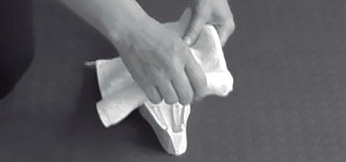 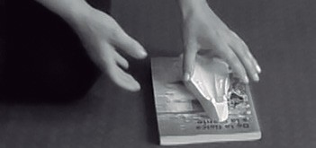

**In order to soften the contact with the device, pro- ceed to place a folded towel on top of the SACRUS. (Only if necessary).**

# * Moderate manner

**To increase pressure place a towel or notebook un- der SACRUS**

Using SACRUS in a moderate manner simply means to control and regulate the pressure being exerted through the use of supports or by applying it on a bed, in order to avoid feeling discomfort.

* You can regulate the pressure by incorporating supports. As pressure decreases, you can begin to remo- ve them slowly (remove one or two books, or place a towel of less thickness).
* Make sure that the spine is positioned directly in the center of SACRUS.
* For greater efficiency, we recommend using SACRUS simultaneously with CORDUS, integrating special exercises depending on your diagnosis and taking supplements to improve your cartilage. Consult with your doctor.

If you experience severe pain during the therapy with SACRUS, it means that your muscles are very spas- med and the joints are severely swollen. Feeling pain while making use of “Sacrus” is very rare! However, in case of severe pain in the sacral region, proceed to place a folded towel or a pillow underneath your waist. This will soften the sacral correction procedure to the maximum. If the pain is unbearable and persistent, you should obtain a diagnosis from your specialist of the causes of such evident inflammation within this area. You will most likely have to take an anti-inflammatory therapy as an initial procedure.

In case of suffering from severe pain when correcting the diaphragm zone, proceed to place a folded towel or a pillow beneath the waist and neck.

If during the session you find it difficult to get up from the device (it may happen sometimes during the first sessions of thoracic correction), you can lie on your side and quickly reposition or remove the device. After the first 2 or 3 sessions you may start to feel a minor pain arising within your spine (device pla- cement tracks), mild nausea, or stinging (a slight burning sensation) in the back. This is usually related

to the activation of the blood flow within the tissues of the spine, restoring the mobility of the vertebral

joints and the activation of the vegetative regulation of the internal organs.

Those with low blood pressure may experience a “slight dizziness” after the therapy because the blood

pressure is reduced.

After conducting a nightly procedure with the SACRUS, your sleep is improved significantly!

It is recommended that you do not perform any physical activity during the next 2 hours after conducting

the correction session of the spine with SACRUS.

# Frequency of use

* Normally SACRUS is used every third day, applying it 3 to 4 minutes on each point (except on contrain-

dicated areas).

* A basic cycle consists of 10 sessions. After a cycle is completed, a one week rest interval is recommen- ded. You can then repeat the cycle over again, or use it once or twice a week.
* Consult with your doctor if you can use it more frequently (every day or in some cases up to twice a day). If your back feels a little sore the next day, do not use the device for 1 to 2 days.

# FICHA TÉCNICA

**Material:** Hypoallergenic plastic ABC

**Weight:** 180g

**Dimensions:** 16 cm. x 8 cm. x 4 cm.

**Magnetization force:** neodymium magnets 01.14 - 01.17 tesla

**County of origin:** Russia.

Do not expose to high temperatures

# SACRUS Basic Application

Regardless of where your back condition is located, we recommend that you apply the device to all of the basic points listed here below (except for contraindicated areas).

Start your therapy by first treating the sacrum, then proceeding to the cervical zone and finally the dia- phragm. You can also complement your therapy by including additional treatable points.

It is important that the spine is correctly positioned and aligned in between the tips of the SACRUS (cente- red).

##### The session can be performed on the floor or on a bed.

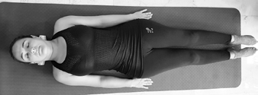

**Be sure to properly align your body correctly**

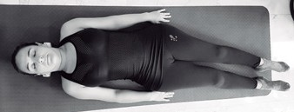

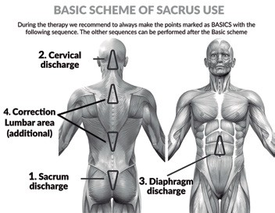**Avoid incorrect positioning**

**BASIC STRUCTURE OF SACRUS USE**

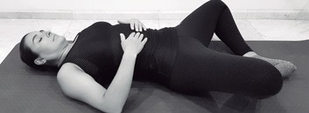

**4**

##### CAUTION! Do not use SACRUS without first rea-

**ding the PREVIOUS PAGES within this manual.**

**Correction of the sacrum-coccyx zone**

First identify points A and B (side X), then locate the last bone of the spine (aligned in the middle of the buttocks). Once you’ve located the bone, gently press against it in order to remember where the point is found. (F1) The points C and D are located at L5 lumbar region level.

**SIDE Y**

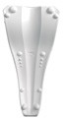

**SIDE X**

1. **Basic:** Frog legs 2 to 3 min. (F 4) If you experien- ce discomfort at the height of the pelvis while being in this position, place a support underneath the legs. (F 5)

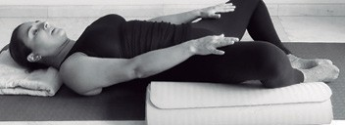

**5**

Once you have identified the correct positions of

the SACRUS, lay on your back with your legs bent. Then gently lift your hips and place the SACRUS on the previous point (f 1.1). Continuo to gradually lower your hips until reaching the surface (remem- ber that you will feel pressure, but never an exces- sive force). Finally stretch your legs out and relax. NOTE: You should always feel a moderate pressure without extreme discomfort. (Depending on the state of your spine, find the right position)

##### IMPORTANT! If any position done with SACRUS causes extreme discomfort, avoid performing it for a certain period of time and continue with the other postures.

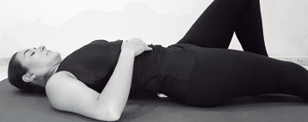

**6**

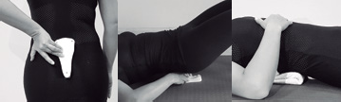

**1**

**1.1**

**1.2**

If you have back problems in the lumbar region or

the use of SACRUS causes you any discomfort, we suggest placing a support (towel) below this area or you can also lay a folded towel on top of the SA- CRUS. (F 1.2)

##### Executing correct postures (SACRUS under the

**sacrum)**

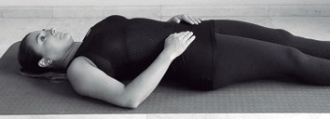

**2**

1. **Additional:** Apply after 5 sessions. Performed the exercise with one leg bent and the other stret- ched out. Repeat the same cycle with the other leg. (2 min. on each leg). (F 6)
   1. **Basic:** Stretched legs 3 to 4 min (F 2)

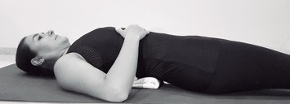

**3**

* 1. **Basic:** Legs bent 3 to 4 min (F 3)

1. **Additional:** Apply after 5 sessions. Hold your leg bent with the opposite hand. Without losing grip, apply a 20-30 % force during 6-8s while trying to stretch out the leg. Then proceed to release, stretch gently and relax. Repeat the same exercise twice on each leg. (F 7)

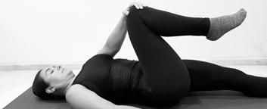

**7**

1. Final exercise without SACRUS: we finalize the treatment of the sacral zone by executing a series of exercises that will once again stabilize and activate the muscles around this area. Accommodate your- self to the initial position (by laying back flat on the surface), bend your legs, hug your knees, inhale and during the exhalation phase bring your head closer and closer towards the knees and hold this position for about 8-10 sec. Do not forget to breathe calmly. (F 8)

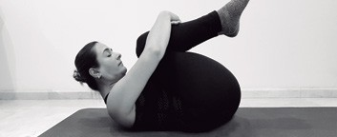

**8 Without SACRUS**

ly, you will feel a slight pull in the cervical zone (f 10.2). Watch video on cordus.com

You can also do the same with your legs bent. As you lower your head onto the device and feel a slight pull, you can straighten your legs out one by one in order to experience a stronger stretch. Re- member that it should not be excessive. Leave the device at this location for 3 min.

**10.1**

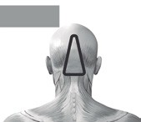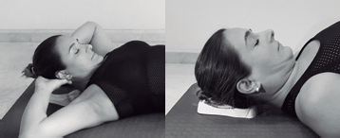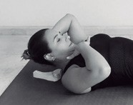

**Cervical Zone Discharge**

**10**

**10.2**

**10.3**

1. In case of suffering from sciatic, hip or leg pain, we recommend that you finish the session with the following exercise: First lie down with your legs stretched. Then bend one knee, inhale and as you exhale, bring your knee closer to your chest with

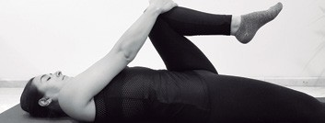

**9 Without SACRUS**

a 20-30% effort force. Make this a reference point for your knee and continue to inhale and exhale. Each time you exhale try to bring your knew closer and closer to the chest. Repeat the same cycle for two minutes on each leg. Try to keep your head laid back flat on the surface and your other leg comple- tely straightened out. (Photo 16)

**Relaxation of the cervical zone (align-**

**ment of the Atlas)**

1. **Basic:** locate points C and D on the SACRUS; the side X of the device should point towards the top of your head. Points C and D should be touching the first cervical vertebrae, found just below the skull. (F 10) Lie on your back, lift your head and place the device on the floor with points C and D on the first cervical just below the skull. (F 10.1) Points A and B do not touch the skull. Straighten the neck upwards with the chin pointing towards the chest and while holding this position, lower your head until it rests on top of the device. If you do everything correct-
2. **Additional:** Maintaining the same position of the SACRUS, proceed to drag it a little further down your head until you begin to feel tips A and B, this is the “bregma” zone (activation point of the skull

where the frontal bone and the parietal bone meet). Adjust the device to only feel a moderate pressure, without experiencing mayor discomfort. Hold this position for 3 min. If you feel too much pressure, you can place a towel on top of the device.

##### See the instructive video at cordus.com

**After concluding your treatment to the cervical zone:** The muscle tone around this area needs to be reactivated. Remove CORDUS, bend your knees and clasp both hands behind your head, inhale and exhale, seeking to bring your chin to the chest with a 20-30% effort; Remain in this position from 8 to 10s while maintaining your respiration! When fini- shed, return slowly to the starting position. Repeat the same cycle with your legs stretched out. (F 11)

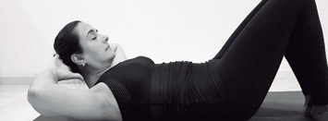

**11**

**Without SACRUS**

## Relaxation of the diaphragm zone

**SIDE Y**

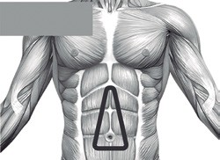

**Diaphragm Discharge**

**After concluding your treatment to the dia- phragm zone:** It is necessary to reactivate the mus- cle tone within this area and give more elasticity

to the diaphragm. First inhale and stretch out the diaphragm region by simply lifting your head and waist upwards while slightly arching your back. You should feel stretching sensation around this dia- phragm zone. (F 13) When inhaling, maintain your respiration and position for 3 or 4 s. Avoid tensing your neck.

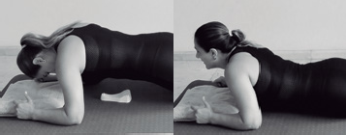

**12**

**12.1**

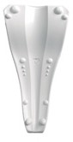

**SIDE X**

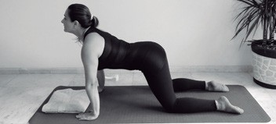

**13**

During the exhalation phase, lower your head and arch your spine upward curving it towards the cei- ling. Hold this position for 3 to 4 sec. (F 14) Repeat these exercises 3 or 4 times each.

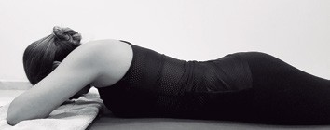

**12.2**

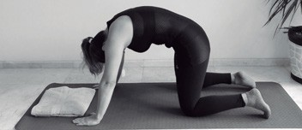

**14**

To properly treat this section with the SACRUS, you will first need to locate the mouth of the stomach in order to place the device below this point (f 12). Then, while maintaining stable with the aid of your elbows gradually lower yourself downward onto the device until you feel that points A and B begin to apply pressure at the mouth of the stomach (f

12.1). If your stomach is too firm, do not lower your body fully onto the device; instead, find a position where you can support a tolerable pressure. Hold this position until your done experiencing discom- fort. This way you can control and regulate the pressure being exerted by simply lowering yourself little by little onto the device (f 12.2). You should follow this same procedure; until you are able to tolerate your own weight. (F 12.3)

##### It is not necessary to achieve this in the first

**session.**

Execute the relaxation process in a moderate and pleasant manner. Breathe calmly. Hold this position for 3 to 4 min. You may cough lightly to help relax the diaphragm.

**In order to obtain a greater therapeutic effect af-**

**ter finishing the therapy with CORDUS, it is advi- sable to avoid standing for long periods of time, so that a vertical load isn’t discharged directly to the spine. In case of having to move to another room, lean on the walls or furniture nearby. You can also rest on a high-backed chair or a bed. Avoid physical activity for the next two hours.**

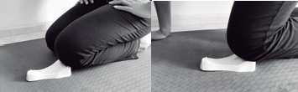

**15**

**15.1**

##### Knee Zone.

The narrow part of SACRUS should be under the kneecap. The wide part of the device should under the start of the shin. (F 15) You can control and regulate the pressure by simply leaning against the floor with one hand. (F 15.1)

## Correction of the Dorsal Zone (additional)

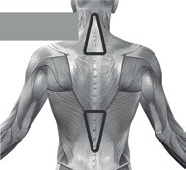

**SIDE Y**

**Dorsal Zone Discharge**

**SIDE X**

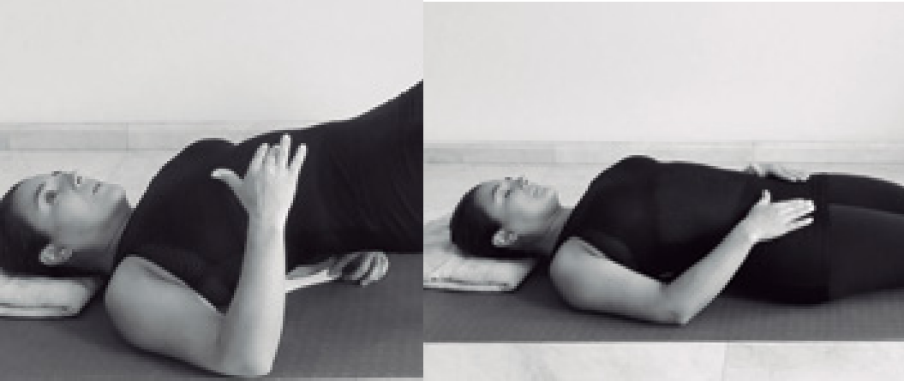

**17**

**17.1**

Correction of the Dorsal Zone (additional)



**X**

If you experience problems within the dorsal area of your back (scoliosis), place the device above the shoulder blades so that points “C” and “D” are alig- ned just above them. Side “X” should face upward and side “Y” downward.

Place SACRUS on a flat surface and while maintai- ning stable with the aid of your elbows gradually lower yourself downward onto the device until fin- ding the correct position. Remember that SACRUS should be centered on your spine.

##### In case of suffering from scoliosis, align SACRUS

**to the axis of the spine. (F X)**

Points “C” and “D “must be situated above the shoul- der blades, 4 to 5 cm (1.6 to 2 inches) below ver- tebra C7 (vertebra that bulges out at height of the shoulders).

Attention: Points “A” and “B” should not making con- tact with any part of your back; they should simply be left hanging without touching the cervical zone. Attention: Points “A” and “B” should not making con- tact with any part of your back; they should simply

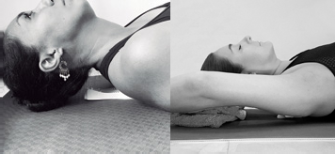

**16**

**16.1**

**General recommendation for thoracic zone:** Remove SACRUS after treating the thoracic zone. In order to reactivate the muscle tone within this area, stretch your legs out and expand your arms behind the head. During 10-15 s, apply a 20-30% effort for- ce while holding and stretching your whole body outwards. Hold your breath! (F 18).

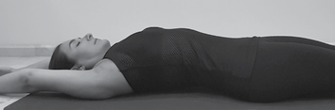

**18**

**Without SACRUS**

##### Relaxation of the Hips:

You can also apply the device below the hips. (Pre- vention of osteoarthritis / arthritis) (F 19)

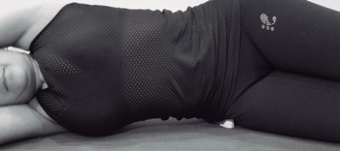

**19**

SACRUS is aligned with the pelvis so that that narrow part of the device is facing forward and its wide part faces backwards. (F 19)

be left hanging without touching the cervical zone. **I**t is recommended to place a support of approxima- tely 3 to 4 cm (1.2 to 1.6 inches) high (towel, pillow, or book) beneath your head. To give more pressure you can stretch your arms behind the head or place

**In order to soften de contact, place a folded towel on top of the SACRUS. (Only if necessary).**

**To view instructive videos visit our website [www.](http://www/) cordus.com**

##### Foot Zone.

The wide part of SACRUS should be under the heel, and its narrow part should be below the metatarsal.

##### Shoulder Blade´s

**Zone.** Y

ou can SACRUS below

the shoulder blades.

**After conducting the first sessions:** you may feel a slight discomfort on a certain point of your back, dizzi- ness or a light burning sensation, this is associated with the activation of the blood circulation within the endocrine tissue, recovery of the articulation´s mobility and the energy activation of the meridians in the spinal cord.

People with low arterial tension may experience a slight dizziness because SACRUS tends to lower blood

pressure a bit.

During or after the session you may experience rare sensations of heat, cold, vibration or something similar in your body. Don’t worry, your nervous chains are reactivating, in one or two sessions this will disappear. It is recommended to use SACRUS in a gentle manner during 2 or 3 sessions.

**FOR BEST RESULTS:**

* Use SACRUS according to your diagnosis. Read as often as necessary and pay careful attention to the entire manual.
* Perform exercises based on your diagnosis: 5 to 10 minutes a day (you can find them in YouTube).
* Take supplements to improve cartilage (consult with your doctor).
* Eliminate bad habits that worsen your problem: poor sitting posture, dehydration, stress, etc.
* Elimine malos hábitos que empeoren su problema: mala postura al sentarse, deshidratación, estrés, etc.

## COMPLEMENTE SACRUS WITH CORDUS

In case of having both devices, SACRUS and CORDUS, it is recommended to first carry out the common SACRUS therapy and then continue with the CORDUS sessions. You can also apply SACRUS one day and another day CORDUS.

## I do not have back pain, why use SACRUS?

Having no back pain does not mean that you are problem free. According to medical statistics, 70% of peo- ple who suffer back problems from hernias, deterioration, spasms, etc. do not experience any pain during several years living with these conditions hidden until the pain suddenly appears at an advanced stage. In some cases surgical intervention is necessary.

One of the characteristics of the deep intervertebral muscles is that they are not able to relax for themsel- ves again after being tensioned. Since childhood, we tend to experience different types of work-overloads, bad emotions, stress, or fear that cause muscular spasms to accumulate and build up within these muscles. These spasms must be treated in order to prevent them from becoming serious diseases and to avoid a decreased performance of the immune system.

Ex: We are all accustomed to brushing out teeth on a daily basis, but we do not have the same habit to take care of the spine even though is the most important system of the body. SACRUS is that “tooth brush” that needs your spine. Initially, it is recommended to perform 1 to 2 sessions in order to remove the spasms that have been silently accumulating in your back. Then you can use the device once or twice a week. SACRUS can become your best anti-stress ally.

## SACRUS as a problem detector

If you experience discomfort in any area of the spine or other part of the body while applying the device, this means that SACRUS has detected the origin of a problem. It is recommended to get a diagnosis from your doctor.

## Diseases of the Internal Organs

SACRUS is an effective complement to the treatment of internal organ diseases. Each vertebra within the spine is connected to a specific internal organ. The brain signal passes thru each vertebrae until reaching the indicated organ and vice versa.

The incorrect alignment of the sacrum with the atlas or tensions within the diaphragm zone can lead to serious illnesses of the internal organs. The basic SACRUS application will help to recover spinal mobility and connectivity within the spine, it restores nervous chains to their functioning state, and it boosts the immune system and flow of energy. It can be a great complement to any treatment.

### Did SACRUS not help? Do you not feel improvement?

Less than 1% of our customers fail to gain results. According to our research, these are some of the rela- ted reasons:

* Incorrect use of the device from not reading the manual carefully.
* Not having a correct diagnosis.
* Not being constant in your therapies with SACRUS.
* If people do not see immediate results, they stop using the device.

**If SACRUS does not help to solve your pain quickly, it may be that your condition requires more sessions.** The device does not cure degenerative diseases, but may help to detain the progression of the condition, which is also a positive result. In these cases, we recommend that you do not stop using the device, but complement it with other types of therapies. Consult with your doctor.

Constant use of the device will improve your spine and the rest of your body. It is like having your own

massage therapist, chiropractor and acupuncturist right at home.

If you obtain good results with SACRUS, do not stop using it. Relax with SACRUS at least once a week. The daily bad life habits generate muscle spasms that eventually lead to several diseases. ***Make SACRUS part of your life.***

## For a more complete and effective treatment use SACRUS with CORDUS.

**What is CORDUS?**

CORDUS is another product created by Russian

doctors, which applies the same self-auto-gravi-

tational method used to reach the deepest mus- cles of the body. It is very efficient when treating herniated discs, 1st and 2nd degree scoliosis, sciatic nerve pain; among other problems. Due to its special innovative design, CORDUS not only treats the deep intervertebral muscles, where neither massage therapists nor chiro- practors can reach, but also adapts perfectly to fit in between each vertebrae. By doing this, the device is able to quickly separate and slightly increase the space amongst each vertebrae. This helps to restore the functionality of the nerves, improve proper blood flow and nourish the in- tervertebral discs in order to able to regenerate them. This effect is very difficult to achieve with traditional methods such as chiropractic treat- ments, massages or other therapies. **More than 300 video testimonials.**

# CERVICAL AREA

## Visit cordus.ru, sacrus.eu

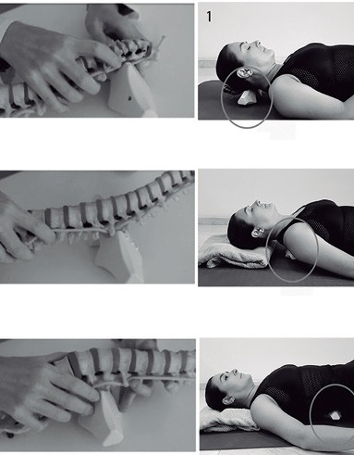

**DORSAL AREA**

**LUMBAR AREA**